**‘CANTEEN MANAGEMENT SYSTEM’**

***A PROJECT***

Submitted in partial fulfilment of the requirements for the award of the degree of

BACHELOR OF COMPUTER APPLICATIONS

BY: -

Jagmohan Mishra (BCA/60001/20)

Prem Raj (BCA/60002/20)

Shivam Vishwakarma (BCA/60003/20)

UNDER THE GUIDANCE OF

**Dr K.N Mishra**

Department Of Computer Science



DEPARTMENT OF COMPUTER SCIENCE & ENGG.

BIRLA INSTITUTE OF TECHNOLOGY

MESRA -835215, DEOGHAR CAMPUS  
(2020-23)

**BIRLA INSTITUTE OF TECHNOLOGY**

MESRA, RANCHI-835215

(DEEMED UNIVERSITY)

EXTENSION CENTER DEOGHAR

**DECLARATION CERTIFICATE**

*This is to certify that the work presented in the project entitled “****CANTEEN MANAGEMENT SYSTEM****” in partial fulfilment of the requirement for the award of Degree of Bachelor in computer Application of Birla Institute of Technology Mesra, Ranchi is an authentic work carried out under my supervision and guidance.*

***To the best of my knowledge, the content of this project does not form a basic for the award of any previous Degree to anyone else.***

Date:

(Guide’s Name &Signature)

Department of Computer Sc & Engg

Birla Institute of Technology

Mesra, Deoghar Campus

**ACKNOWLEDGEMENT**

At every outset we express my gratitude to almighty lord for showering his grace and blessings upon me to complete this project.

We wish to place on my record my deep sense of gratitude to my project guide, DR. KN Mishra for his constant motivation and valuable help through the project work.

We would specially like to express my gratitude Prof. Arbind Kumar Choudhary project co-ordinator for his valuable suggestions and advices throughout the project.

We would like to express our special gratitude and thanks to out institution for giving this opportunity to work on such creative project.

Although our name appears on the cover of this report, many people had contributed in some form or the other form to this project Development. we thank you all.

Finally, our thanks and appreciations go to our project member for their co-operation to completing this project.

Name Roll No Signature

Shivam Vishwakarma BCA/60003/20

Jagmohan Mishra BCA/60001/20

Prem Raj BCA/60002/2

**BIRLA INSTITUTE OF TECHNOLOGY**

MESRA, RANCHI-835215

(DEEMED UNIVERSITY)

EXTENSION CENTER DEOGHAR

**CERTIFICATE OF APPROVAL**

*The foregoing project entitled “****canteen management system****”, is hereby approved as a creditable study of research topic and has been presented in satisfactory manner to warrant its acceptance as prerequisite to the degree for which it has been submitted.*

*It is understood that by this approval, the undersigned do not necessarily endorse any conclusion drawn or opinion expressed therein, but approve the project for the purpose for which it is submitted.*

_______________ _______________

(Internal Examiner) (External Examiner)

_____________

(Director)

**Table of Contents**

1. Introduction 7

1.1 Abstract 7

1.2. Existing System 8

1.3. Proposed System 9

1.4. Scope Of System 10

1.5. Objectives 11

1.6. Need of the System 12

2. Environment 13

2.1. Hardware 13

Table 2.1 13

2.2. Software 13

Table 2.2 13

3. System Analysis and Design 14

3.1. Use Case Diagram 14

3.1.1 Admin 15

3.1.2 Customer 16

3.2. ER Diagram 17

3.3. State Chart 18

3.3.1. Admin 18

3.3.2. Customer 18

3.4. Data Flow Diagram 19

3.4.1. DFD Level 0 19

3.4.2. DFD Level 1 20

3.4.3. DFD Level 2 21

3.4.4. DFD Process Decomposition 23

3.5. Sequence Diagram 24

3.5.1. Registration & Login 25

3.5.2. Login 26

3.5.3. Updating Menu 27

3.5.4. Placing Order 28

4. File Database Design 29

4.1. Admin 29

4.2. Order 29

4.3 Food 30

4.4. Customer 30

5. Screen layout and Design 31

5.1. Login page 31

5.2. User Registration page 31

5.3. User homepage 32

5.4. Food Menu Page 32

5.5. Order Page 33

5.6. Payment Page 33

5.7. Admin Homepage 34

5.8. Admin Manage Order page 34

5.9. Manage Admin Page 35

5.10. Manage Food Page 35

Source Codes 36

Fig no. i 36

Fig no. ii 36

Fig no. iii 37

Fig no. iv 37

Fig no. v 38

Fig no. vi 38

6. Conclusion 39

7. Future Scope 40

8. References 41

# Introduction

## 1.1 Abstract

Today’s fast paced world food and take-out, people prefer quick delivery of food service. No one wants to stand in a long line waiting for order confirmation. Many canteens choose to focus on fast delivery of orders.

Canteen Management System, which is a technique of ordering foods online. This system greatly simplifies the ordering process for both customer and canteen. When the customer visits the webpage, they are presented with an interactive and up-to-date menu. This system will be very much helpful to the canteen's end also as the entire process of taking orders is managed.

Canteen management system is to provide fast services to their college students, Staffs etc. Usually, People have to go to canteen and order the foods and they have to wait in queue for a long time to get the orders, but with the help of this you just have to follow a very simple process to order your stuffs. And you need not to wait in the long queue. A canteen facility is a supplementary system that is provided by organizations for their employees/students.

## Existing System

The existing system is a cash and paper-based system. The payment and process take a lot of time as the customer has to pay the exact amount and wait for the change. If the change is not available at the time, a coupon is provided which should be shown at the counter at the next purchase.

## Proposed System

This system is generally advantageous for avoiding spending time waiting in the queue by posting orders directly to the kitchen without delay and also by scheduling orders ahead of time. It saves time and also the technique dealing with is easy.

The proposed Canteen Management System is an adept solution for chaos at college canteens. Some extent unravels the motivation behind the proposed system.

## Scope Of System

• To get digitalized in College Canteen.

• Develop the technology in our college

• The users will be provided with GUI from where they can select a menu.

• Easy to understand by user and Operator

## Objectives

The main objective of the project on canteen management system is to

Fast and Responsive System

Dynamically adjusting prices based on selection

Real - Time orders retrieval placed on the webpage

User friendly GUI

It tracks all the details about the Item, Stock, Sales.

Functionalities provided by Canteen Management System are as follows:

Provides the searching facilities based on various factors Such as Category, Food. Manage the information of Category, Stocks & Food. Editing, adding and updating of Records is improved which results in proper resource management of Canteen data. Integration of all records of Sales.

## Need of the System

• Helps in advance planning.

• Reduces Administrative works.

• Saves time & improves employee.

• Reduces Wastage of food items.

• Provides a fast and efficient service.

• Increase customer satisfaction.

# Environment

## 2.1. Hardware

|  |  |
| --- | --- |
| **Name** | **Details** |
| Processor | 64-bit |
| RAM | 4 GB |
| Hard Disk |  |

### Table 2.1

## Software

|  |  |
| --- | --- |
| **Name** | **Details** |
| Operating System | Windows 10 |
| Database | Microsoft Access |
| Technology | Visual Studio code 2019 |

### Table 2.2

# System Analysis and Design

## 3.1. Use Case Diagram

A use case is a description of how end users will use a software code. It describes a task or a series of tasks that users will accomplish using the software and includes the response of the software to user action

### 3.1.1 Admin

### 3.1.2 Customer

## ER Diagram

An entity-relationship (ER) diagram is a specialized graphics that illustrates the interrelationships between entities in database. ER diagram often use symbols to represent three different types of information. Boxes are commonly used to represent entities. Diamond is normally used to represent relationship and ovals are used to represent attribute

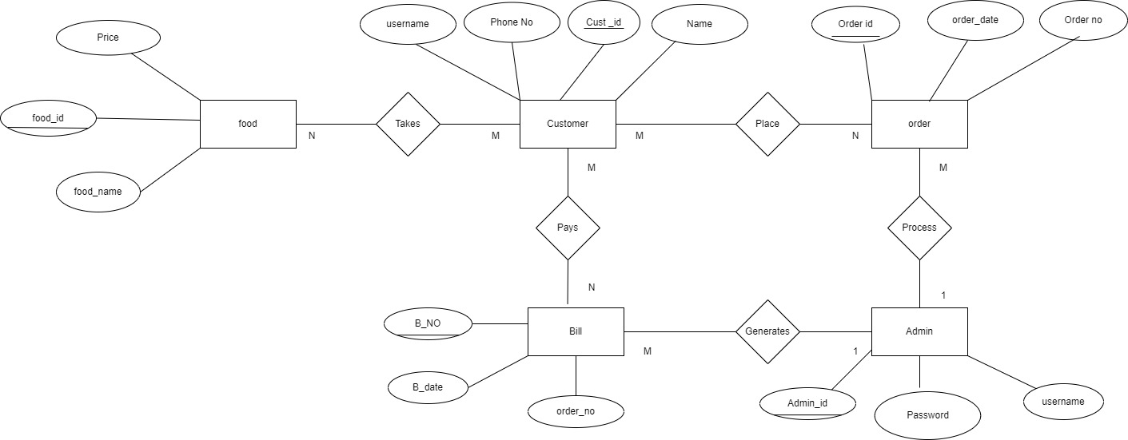

## State Chart

### Admin

### Customer

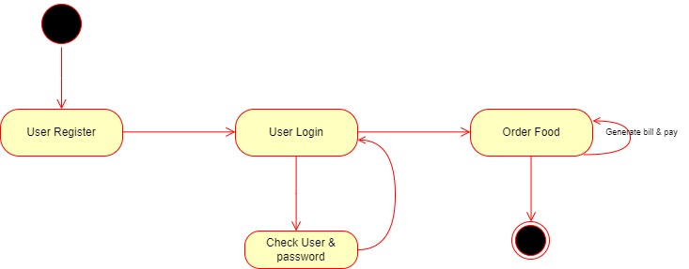

## Data Flow Diagram

A data flow diagram (DFD) maps out the flow of information for any process or system. It uses defined symbols like rectangles, circles and arrows, plus short text labels, to show data inputs, outputs, storage points and the routes between each destination. Data flowcharts can range from simple, even hand-drawn process overviews, to in-depth, multi-level DFDs that dig progressively deeper into how the data is handled. They can be used to analyse an existing system or model a new one. Like all the best diagrams and charts, a DFD can often visually “say” things that would be hard to explain in words. While they work well for data flow software and systems, they are less applicable nowadays to visualizing interactive, real-time or database-oriented software or systems.

### DFD Level 0

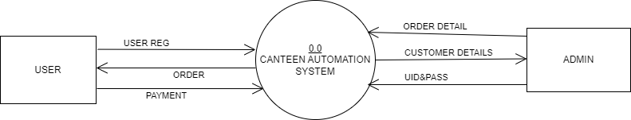

### DFD Level 1

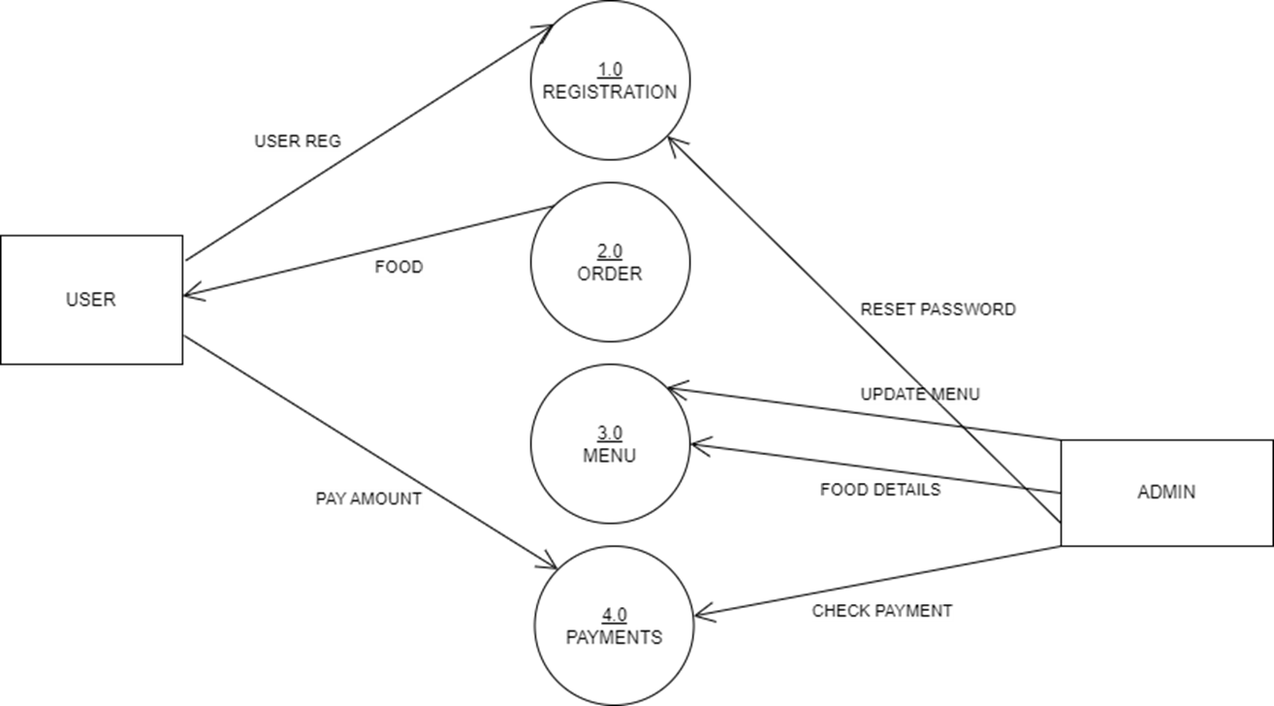

### DFD Level 2

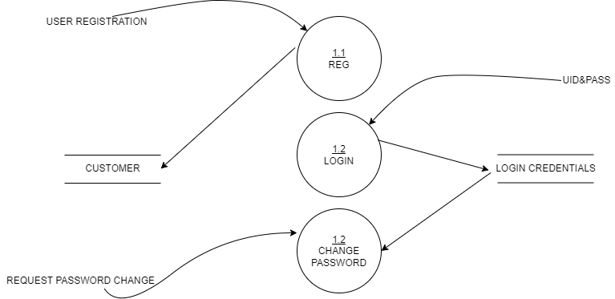

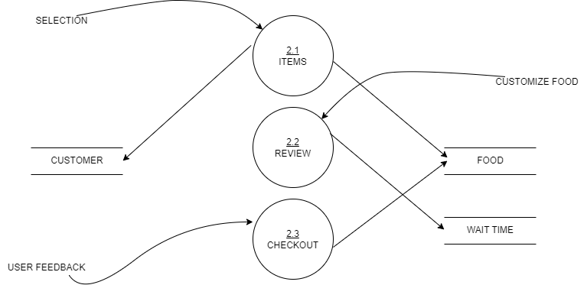

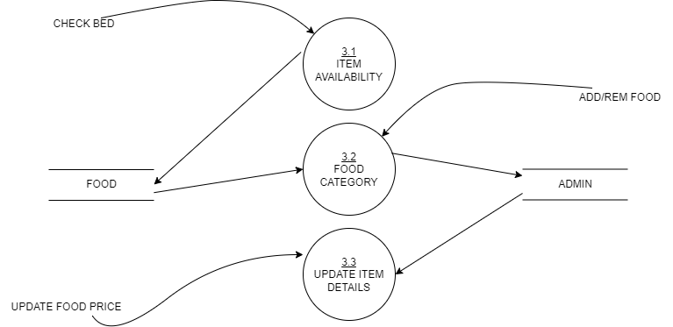

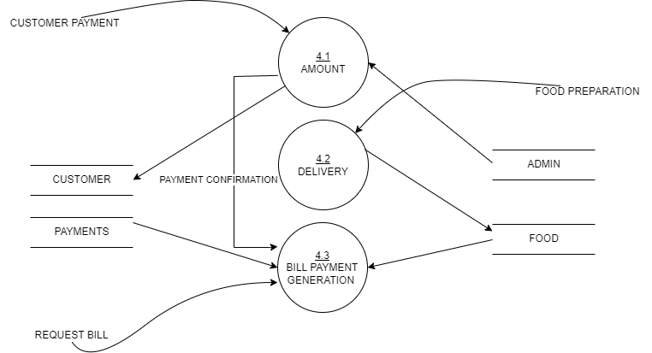

### DFD Process Decomposition

## Sequence Diagram

A sequence diagram in unified modelling language (uml) is a kind of interaction diagram that show a how processes operate with one another and in what order. It is a construct of a message sequence chart. Sequence diagram are sometimes called event diagram event scenarios, and timing diagram

### Registration & Login

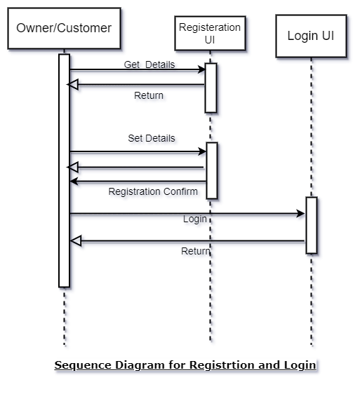

### Login

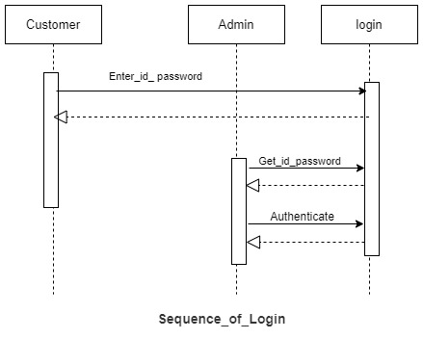

### Updating Menu

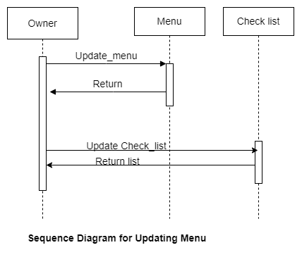

### Placing Order

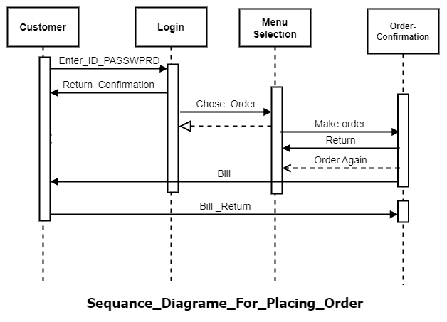

# File Database Design

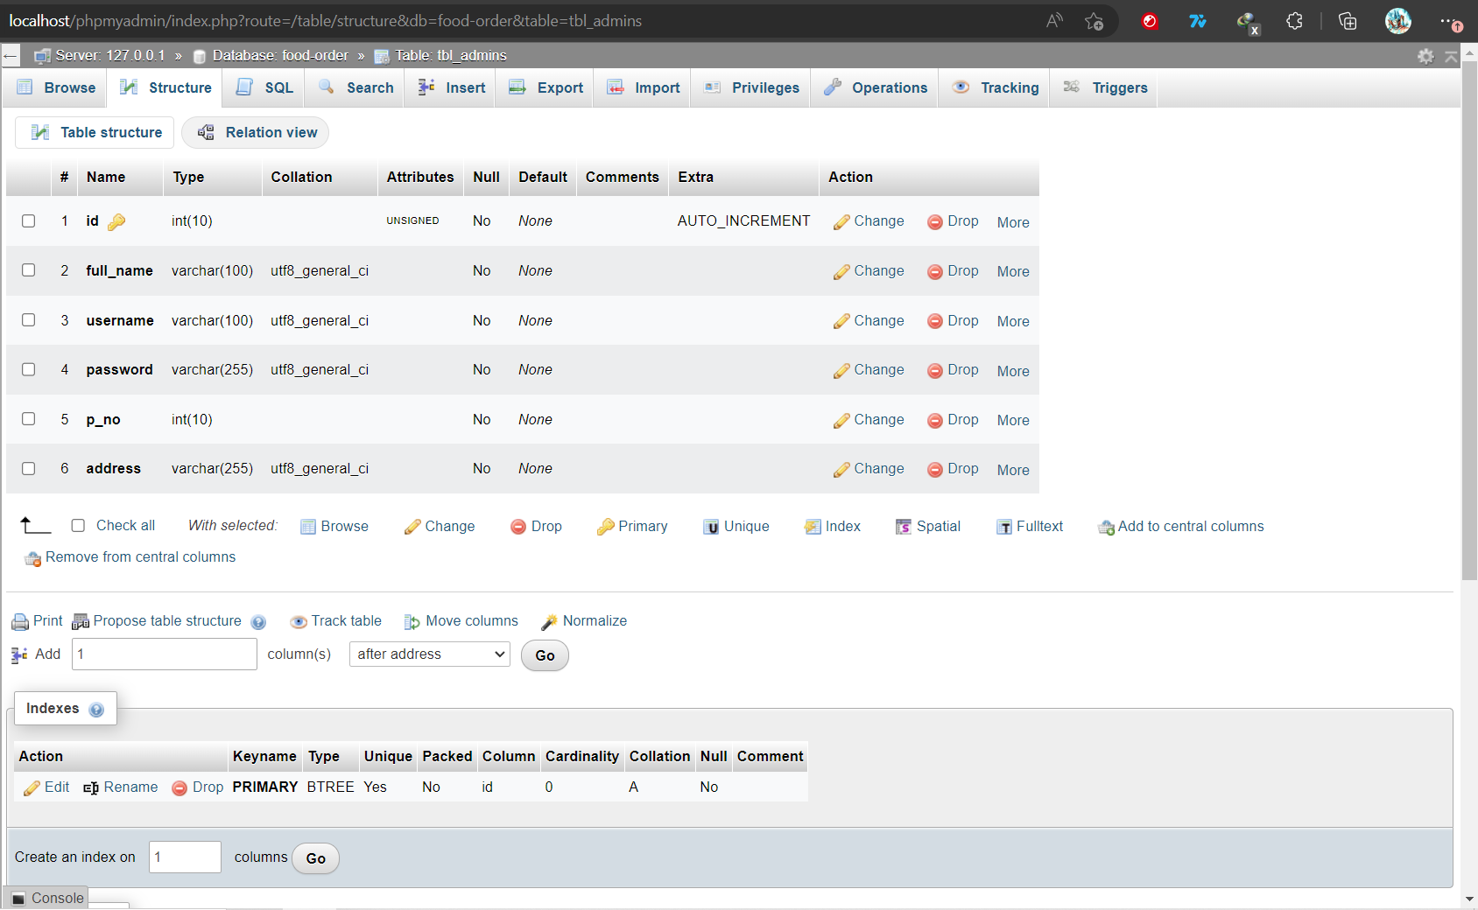4.1. Admin

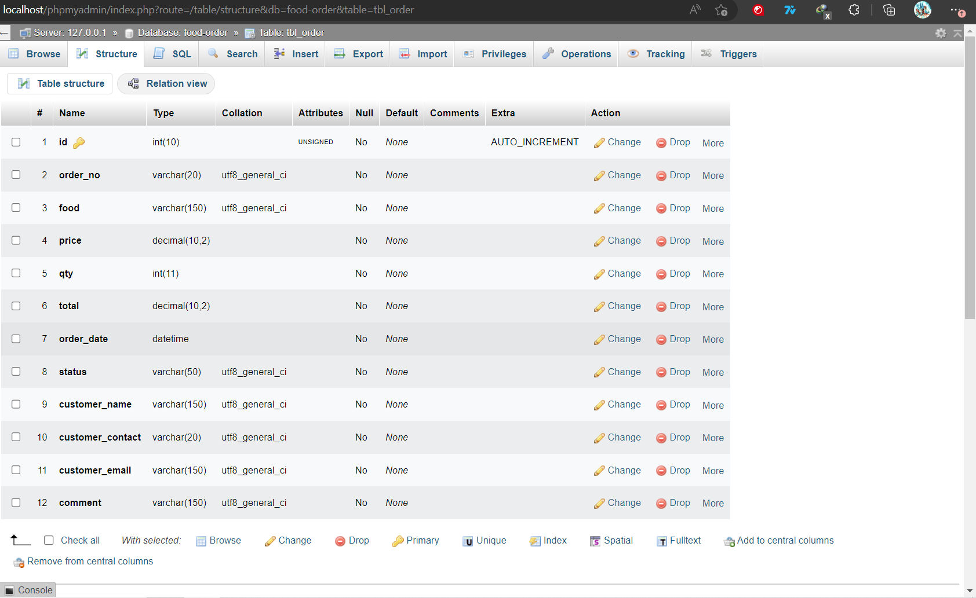4.2. Order

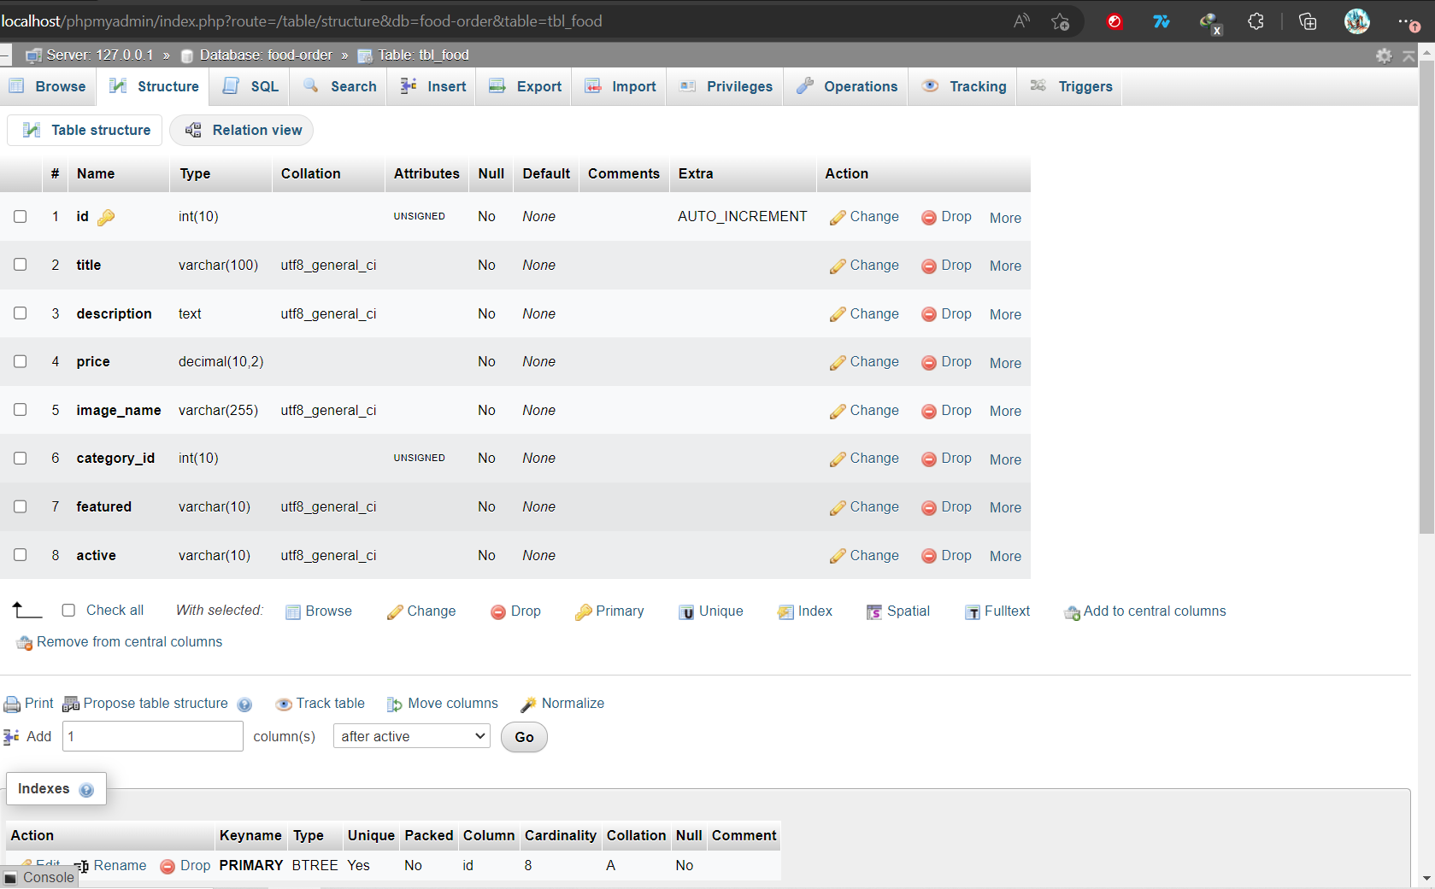4.3 Food

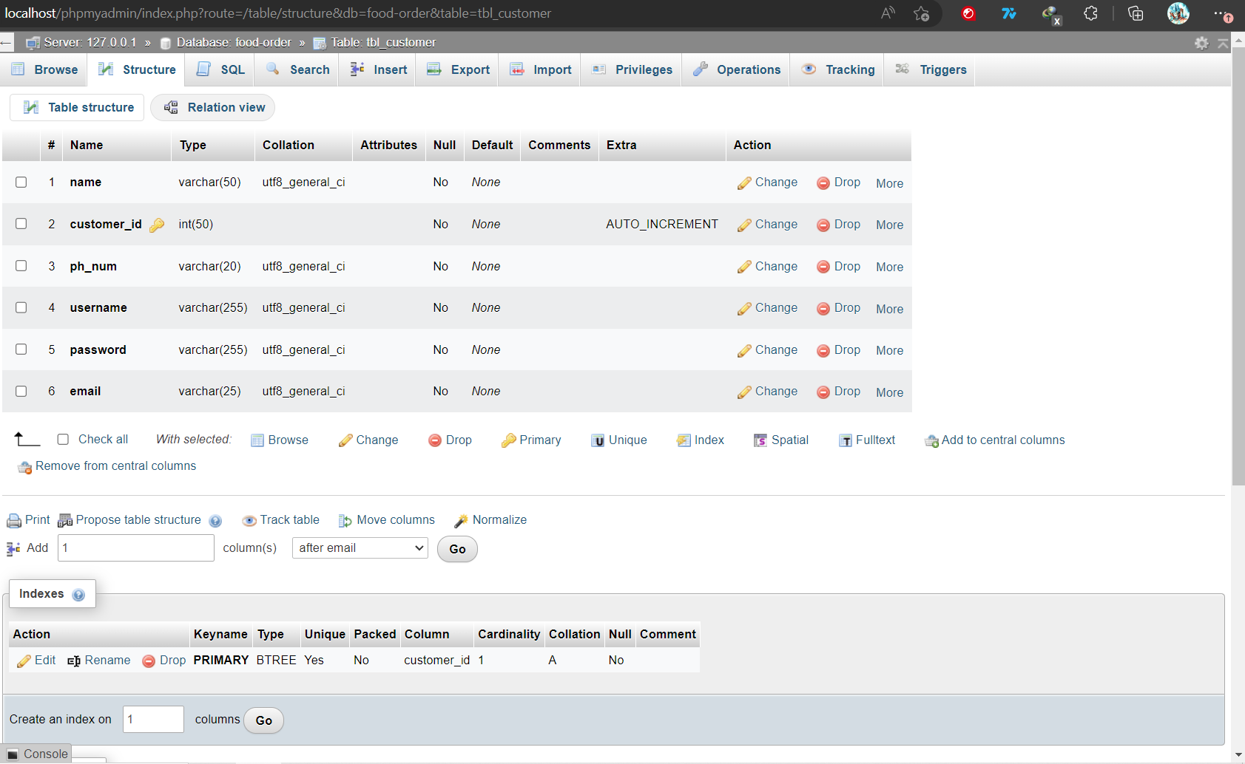4.4. Customer

# Screen layout and Design

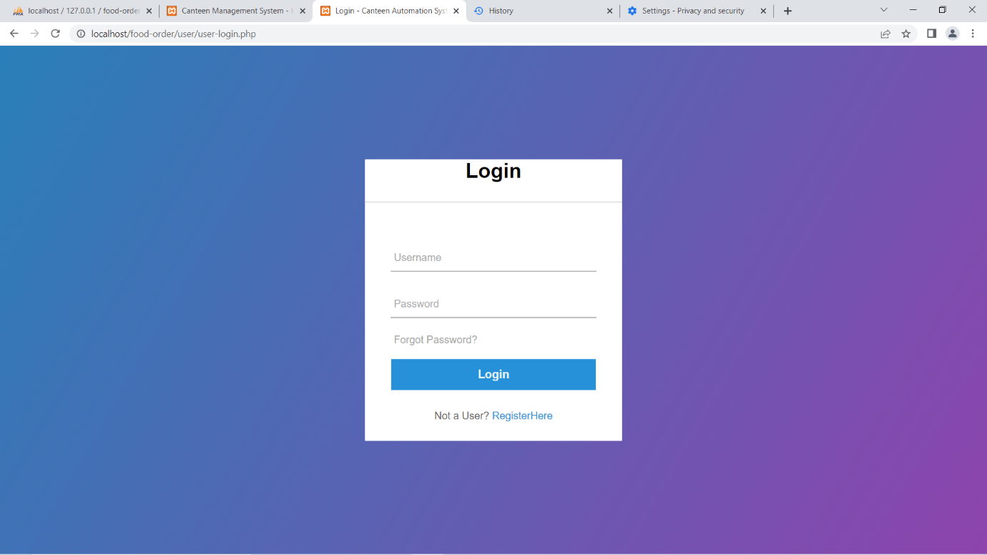5.1. Login page

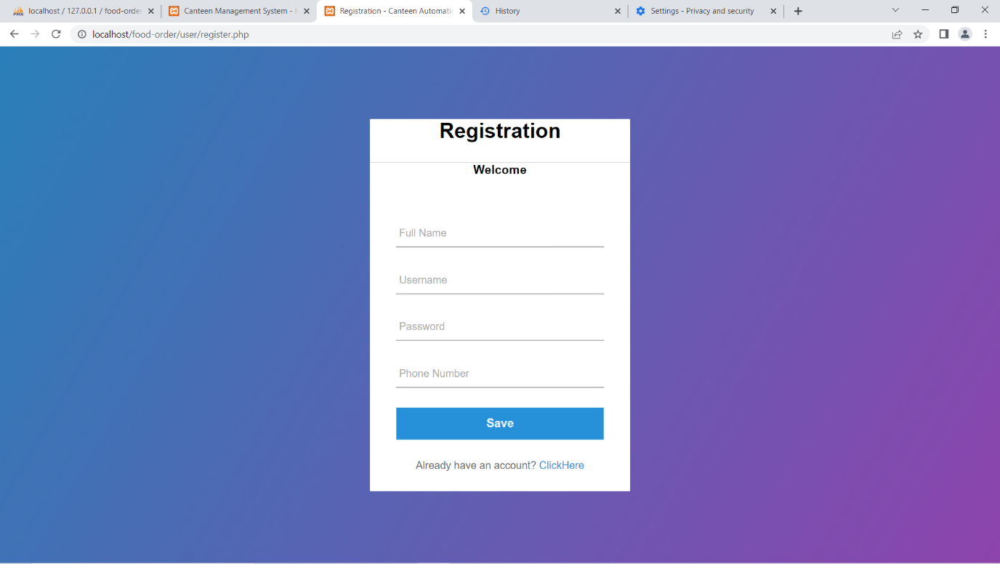5.2. User Registration page

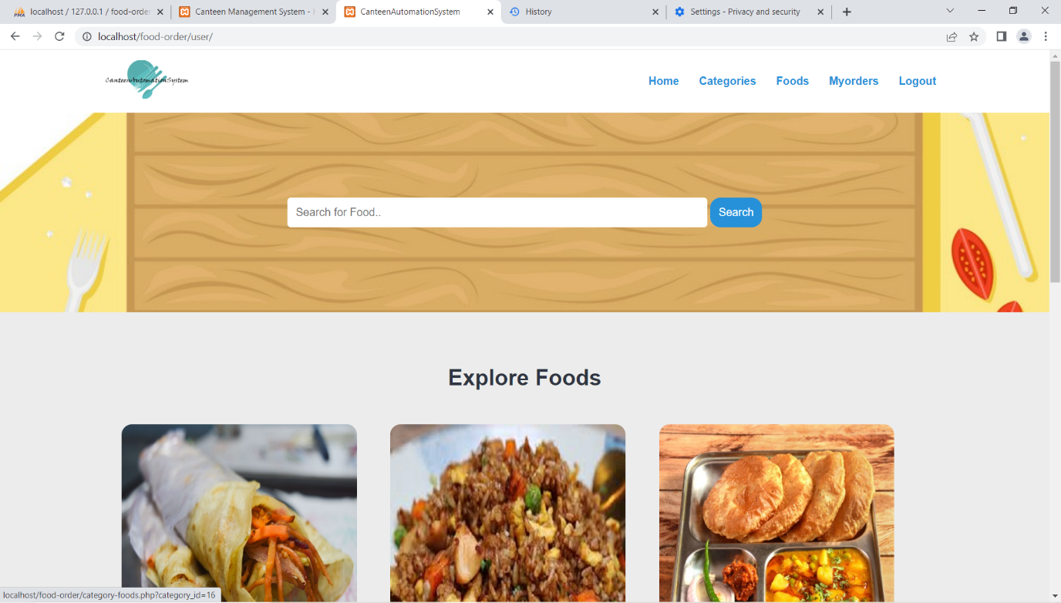5.3. User homepage

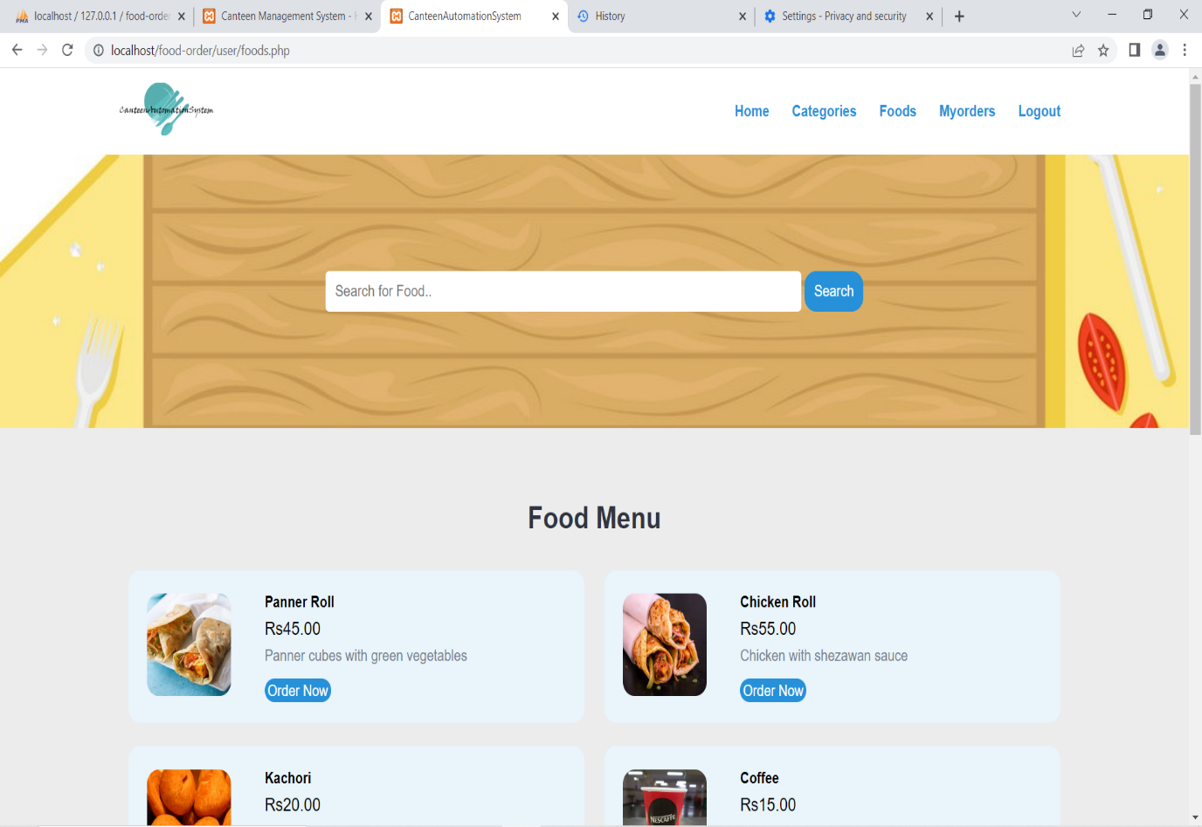5.4. Food Menu Page

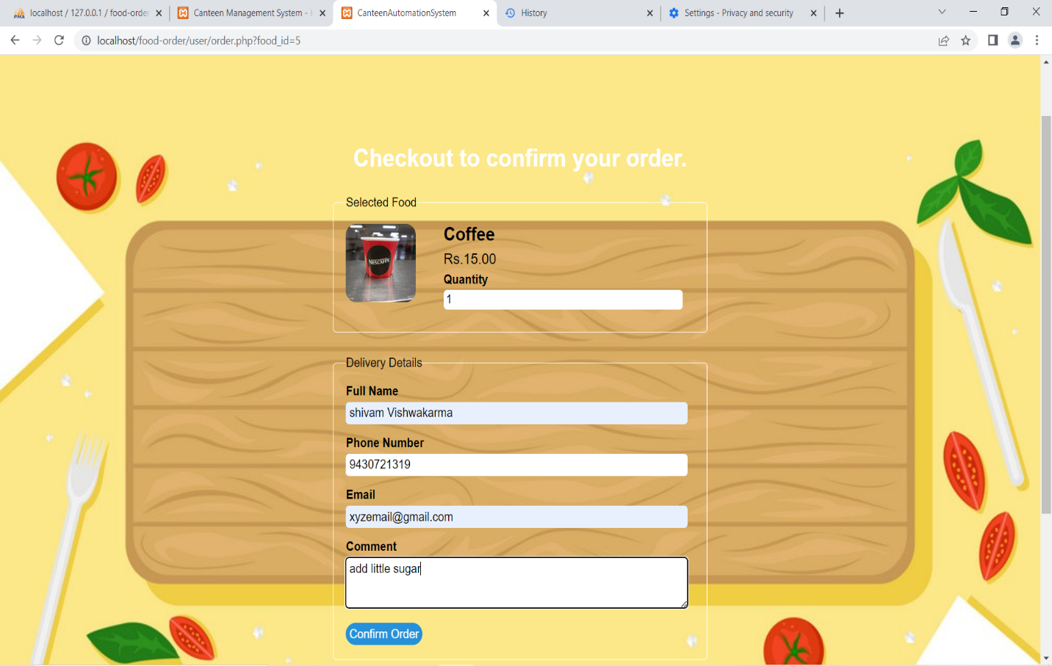5.5. Order Page

5.6. Payment Page

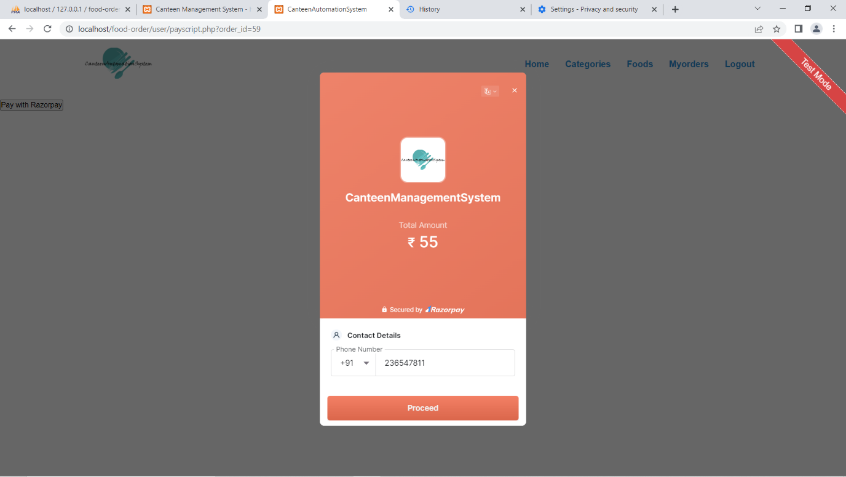

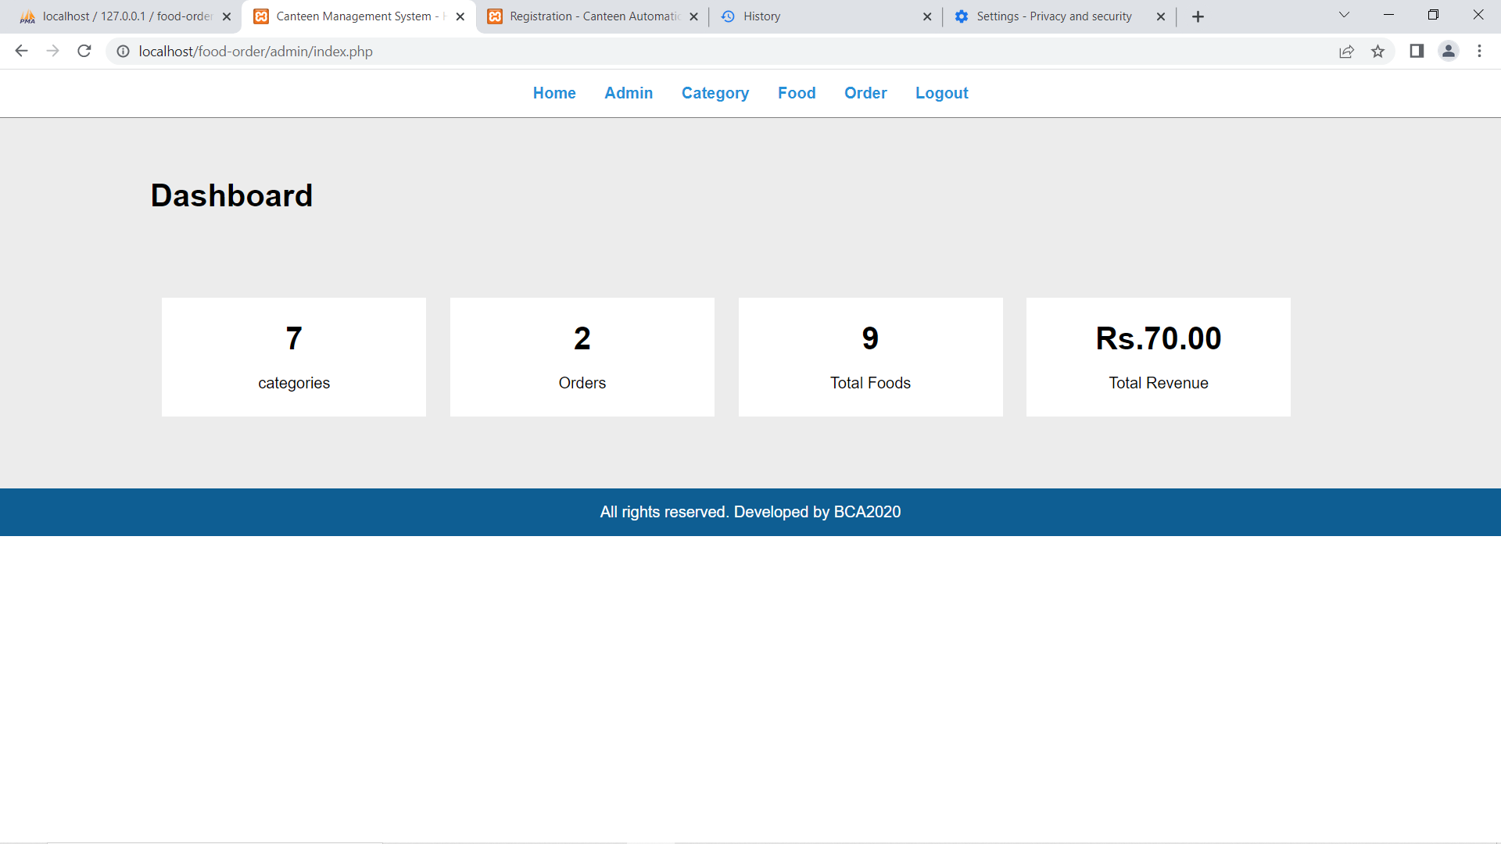5.7. Admin Homepage

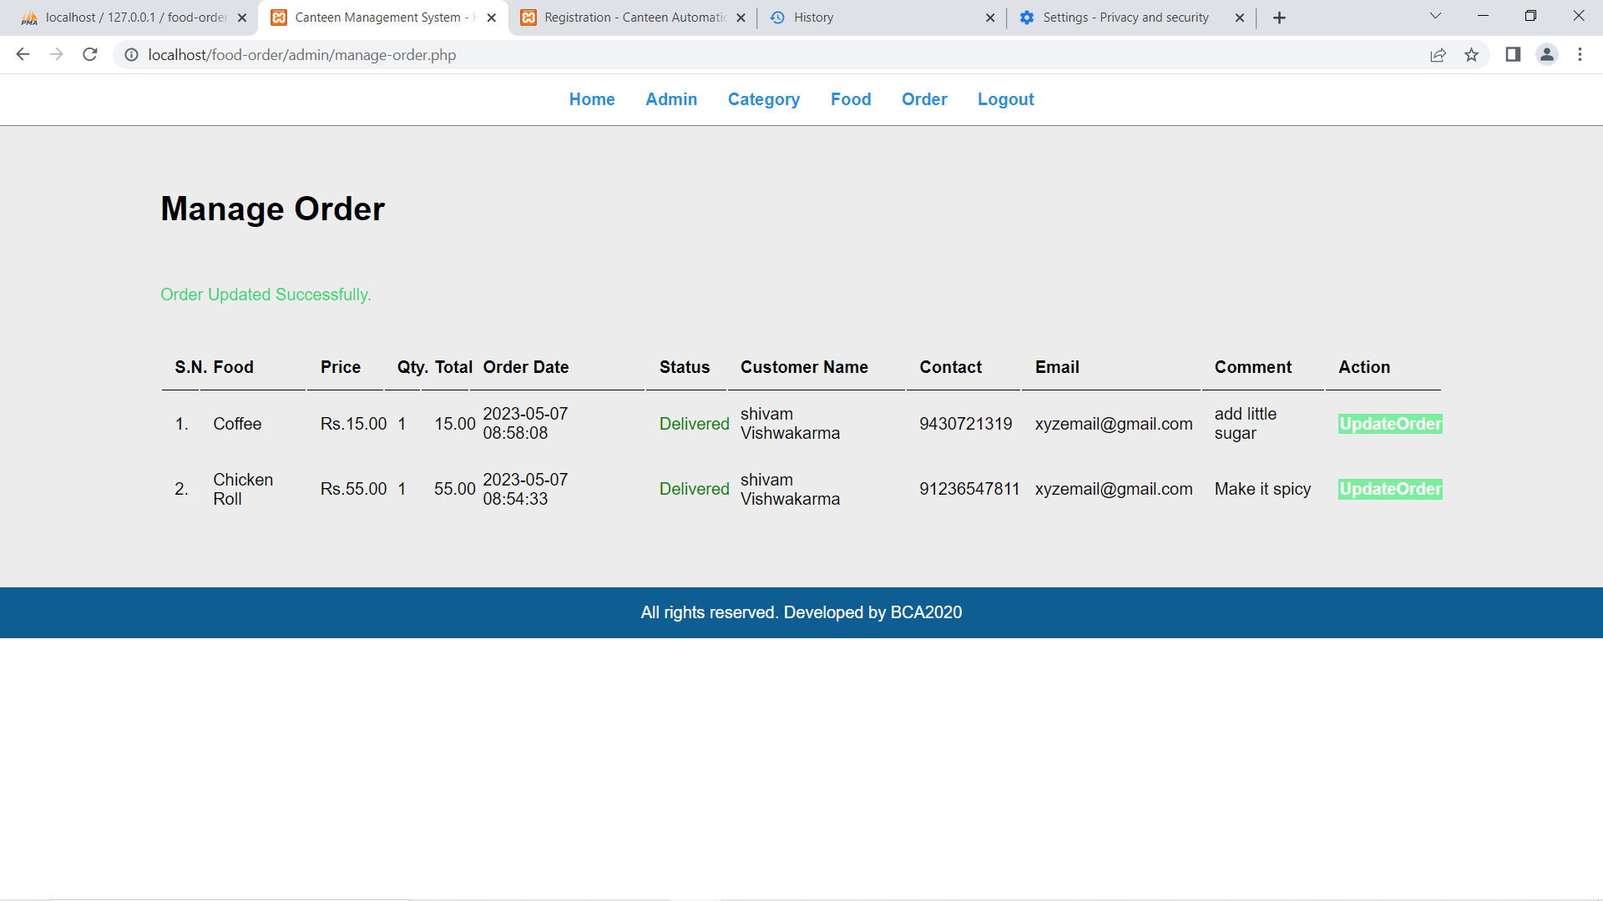5.8. Admin Manage Order page

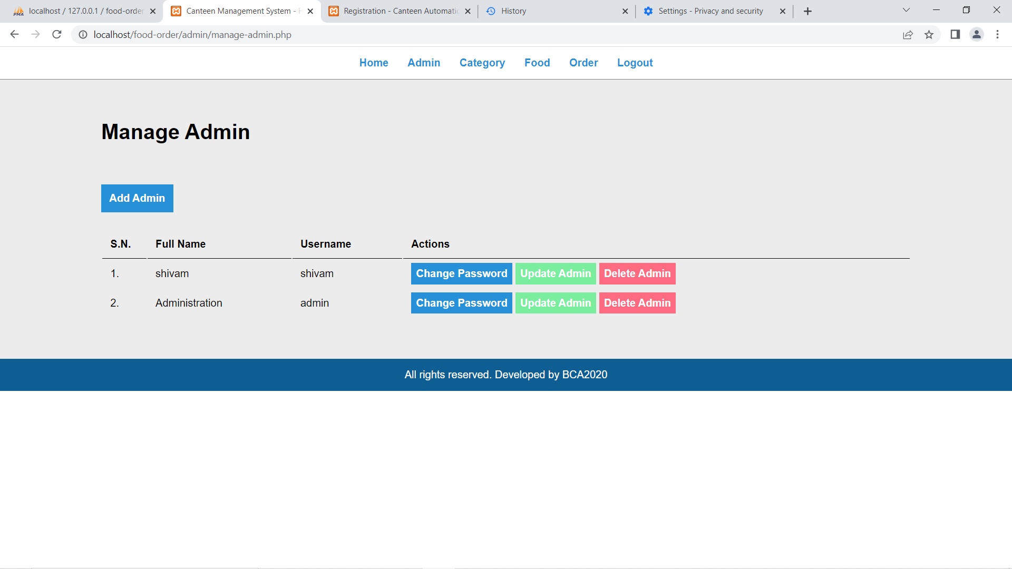5.9. Manage Admin Page

5.10. Manage Food Page

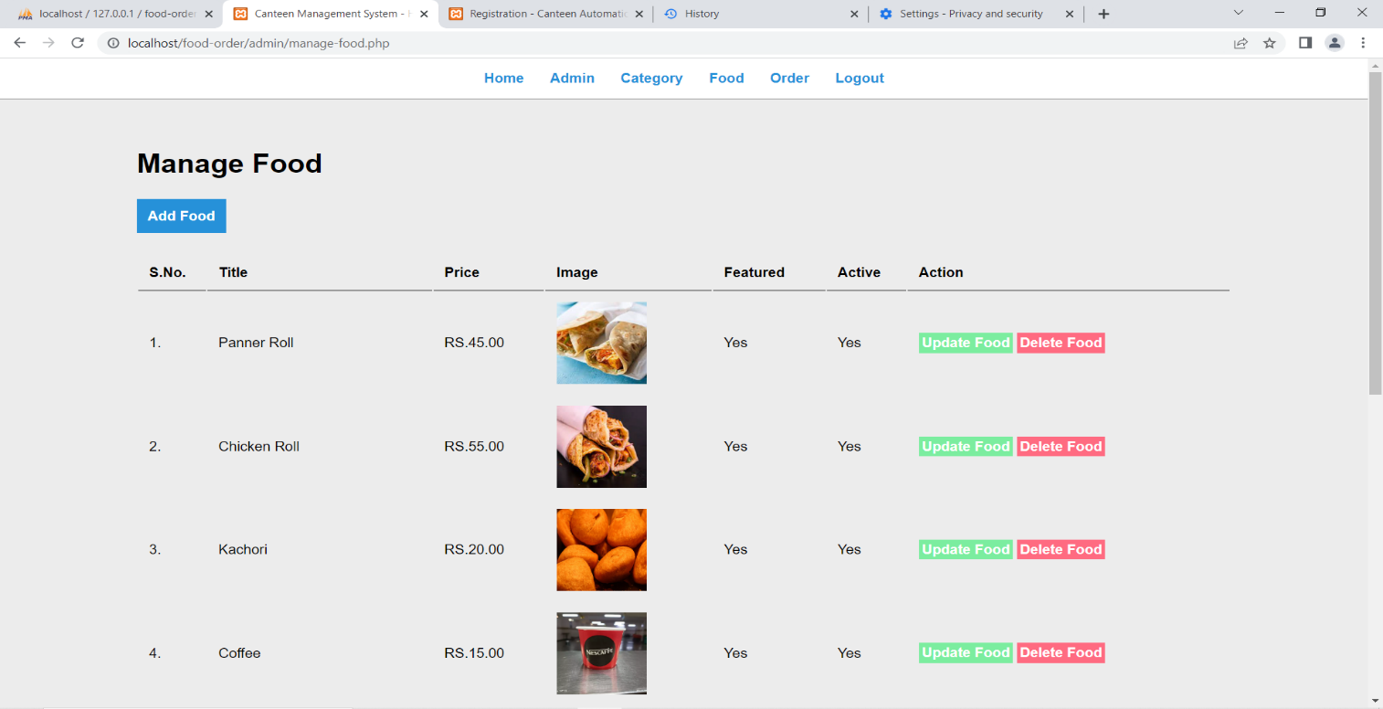

# Source Codes

## Fig no. i

## Fig no. ii

## Fig no. iii

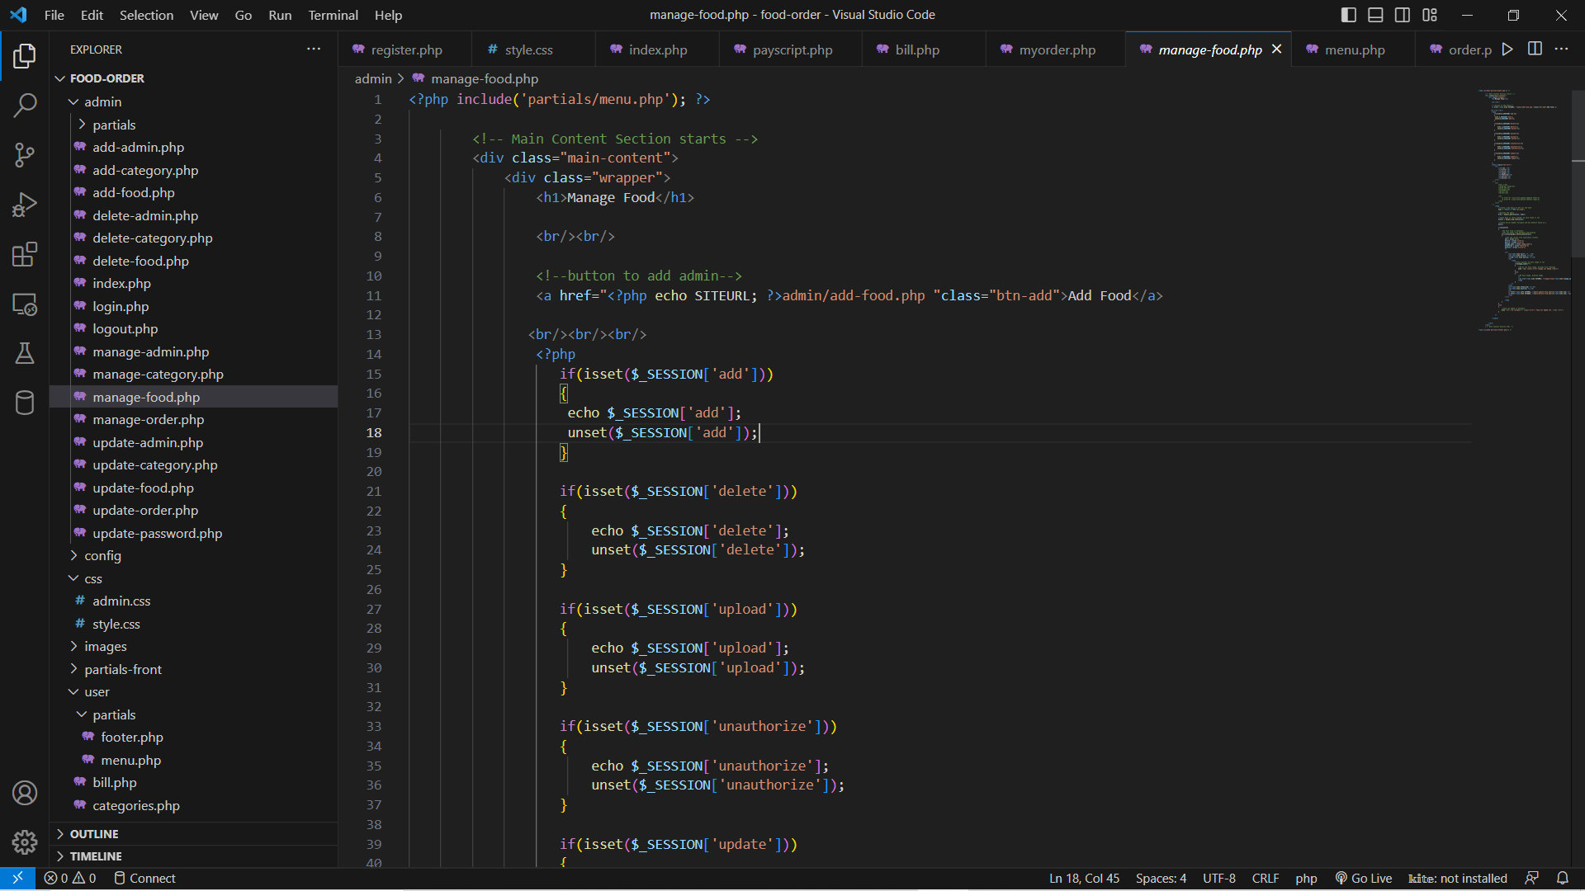

## Fig no. iv

## Fig no. v

## Fig no. vi

# Conclusion

• The development of Canteen Management System involved many phases. The approach used is a top-down one concentrating on what first then how and moving to successive levels of details.

• The first phase started with a detailed study of the problems and prospects of ordering in Foods.

• This Software is efficient in maintaining customer’s details and can easily perform operations on platform.

• This Platform Provides admin’s basic functionality

Which mainly focuses on Overall details of Order and Revenue generated.

# Future Scope

1. In future we will try to add customer profile and also admin profile.

1. Some more interesting features will be added so that students will find it as more useful.
2. We will host the platform on online server to make it accessible.
3. We will add printer to print the bill.
4. We Will add client Side and Server-Side validation.
5. We will add cancel method in order cancellation.
6. We will add food delivery tracking system.

# References

1. Fundamentals of software Engineering- Rajib Mall
2. [www.stackoverflow.in](http://www.stackoverflow.in)
3. [www.geeksforgeeks.com](http://www.geeksforgeeks.com)
4. [www.scibd.com](http://www.scibd.com)
5. [www.draw.io](http://www.draw.io)